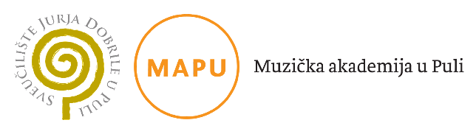

**APPLICATION FORM**

**Eight International Symposium of Music Pedagogues**

**Conference fee**

**Information about the institution:**

|  |  |
| --- | --- |
| Name of institution |  |
| Address |  |
| Postal code and city |  |
| Organisation PIN |  |
| Contact telephone/mobile  phone number |  |
| Contact e-mail address |  |

**Information about the participant:**

|  |  |
| --- | --- |
| Name and surname |  |
| Participant’s PIN (n/a for  foreign participants) |  |
| Residence address |  |
| Postal code and city |  |
| Contact telephone/mobile  phone number |  |
| Contact e-mail address |  |

**Mark where necessary:**

□ expenses borne by institution □ e-invoice

□ expenses borne by participant

*Important notice: The invoice will be sent after we receive your application form and the prove of the payment.*

Date: ___________________ 2023 Authorisation of institution:

**Payment details:**

**Juraj Dobrila University of Pula**

Zagrebacka 30

52100 Pula

**IBAN:** HR1923600001101931377

**SWIFT:** ZABAHR2X

**Payment description:** **SYMPOSIUM MA, name of the participant**

* **Conference fee: 70 €**

*The filled in and signed application as well as the document in which the payment*

*is visible should be sent* ***until April 10th 2023*** *to the e-mail***:**

[**sabina.vidulin@unipu.hr**](mailto:sabina.vidulin@unipu.hr)